**This document is not complete, please add what is necessary and removed all un-necessary things, I might have add useless thing unaware. Please edit it. There use cases that needs to be added, some needs to be edited.**

**4 Architecture requirements**

**4.1 Access channel requirements**

It is going to be accessed by humans using android and web application. The application will communicate with a cloud-server-system that provides a DBMS and a platform that allows information to be display to the users. We have so far been using AfriHost Web Services as a platform for the above mentioned requirements. AfriHost offers a platform with all the necessary tools for us to specify the type of connection or service needed and to provide us with an infrastructure to manage these services.

**4.2 Quality requirements**

**• Security**

– Authentication

∗ The users have to have an account in order access the application; this will provide the users with a username and password. These associated pieces of information are important as they will be required for the authentication process i.e. logging. – A user will have to provide his or her username as well as their associated password in order for them to be logged in and for a session to be created for them

– Integrity

∗ Information captured will be encrypted before sent to the database.

∗ The images that are captured on the device, should be checked if they were altered before they are uploaded to the server.

– Authorization

∗ Tokens (Access Controls) will be assigned to each user, irrespective of the sort of account that they may hold. The tokens determine the user’s privileges, they also determine what the user is allowed to read e.g view all the cases or just specific ones.

∗

|  |  |
| --- | --- |
| Tokens | Privileges |
| 1 | Administrator |
| 2 | Forensic practitioner |
| 3 | Forensic officer |
| 4 | Students |
| n | Guests |

– System users will have different permission.

– Information stored by forensic officers will not be edited after the submission.

**• Auditability**

– The system should record all the changes made to the data stored, by showing whom, when and what was changed.

– It will also show old and new values.

**• Scalability**

– The web hosting server supports 500GB traffic.

– It should allow additional templates.

**• Performance**

– The system should process all the reports within 10 seconds.

– It should send the information to the server within seconds.

**• Reliability**

– The system should be up and running all the time.

– Easy and fast access to the database.

**• Usability**

– Users should be able to use the system without prior training.

– The system will be in English.

**• Maintainability**

– The system will be maintained every time the client needs new changes.

**4.3 Integration requirements**

• Database will be created from scratch.

• The android application will be connected to the web service and the web service connected to the server.

**4.4 Architecture constraint**

• The device that will be used is Asus nexus 7

• Android SDK

• Afrihost

• Java

• The mobile client must be running on an android application.

**5 Software Architecture Documentation**

**5.1 Architecture requirements**

**5.1.1 Architectural scope**

The database will run on Afrihost.

Android app - The android application will be used to capture information on death scenes. Also used to view information based on clearance.

Web app - will be used for data management, report generation, and system administration.

Web service – php web service will be connecting the android and web application with the back database.

MySql database – it will store all data captured by android app and web app interactions.

**5.1.2 Quality requirements**

Security - Only authorized people should be able to have access to the system. Only administrator should register people.

Auditability - Any change made to data stored should be recorded. The system should record what, who and when changes were made.

Performance - Data should be sent in real time e.g. from forensic officer to forensic practitioner should receive it within 10 seconds.

Reliability - The server should run all the time (24 hours a day) and the connection should always be active.

Usability - All the users should be able to use the system without any prior training.

**5.1.3 Integration and access channel requirements**

Access Channel - Accessible by humans through the following channels: web application through web browsers and mobile application through android tablet device.

Integration Channel - The new SQL database will be created in Afrihost.

**5.1.4 Architectural constraints**

The system will use the following constraints:

- Android SDK and REST web services. The system will be deployed in Asus Nexus 7 OS Android 4.1 jelly bean.

Technologies to be used: - Java, PHP, HTML, JavaScript, MySQL, JQuery, CSS

**5.2 Architectural Pattern(get them from rhino spec)**

**5.3 Use of reference architectures and frameworks(get them from rhino spec)**

**6 Functional Requirements**

**6.1 Introduction**

This section introduces the detailed functional requirements of the proposed system. It also shows the use case diagrams for each sub system and the lower level processes that needs to be included to complete the functionality of the sub systems.

Priorities

Low: Not vital to the functioning of the system.

Medium: Standard system feature.

High: Critical feature

**6.2 Required functionality**

|  |  |
| --- | --- |
| Requirement name [1] | User Login |
| Priority | High |
| Description | Only people with valid user account details should log on to the system. |
| Motivation | We want to have control on who logs on the to system and does what. This is extremely important in order to maintain the integrity of the system. |
| Dependencies | User registration [2] |

|  |  |
| --- | --- |
| Requirement name [2] | User registration |
| Priority | High |
| Description | User can only be registered by administrator. |
| Motivation | We are restricting public and un-trusted parties to register on the system. Only specific trusted individuals must be registered on the system. |
| Dependencies |  |

|  |  |
| --- | --- |
| Requirement name [3] | Data input and submission |
| Priority | High |
| Description | The user must be able to complete all fields of a form so that it can be submitted successfully. |
| Motivation | The application make use of google maps, weather service and camera when collecting data from the scenes. All this features must attached on the form so that it can be successfully completed. |
| Dependencies | GPS Location and time [4], Weather Services [5], Camera Integration [6] |

|  |  |
| --- | --- |
| Requirement name [4] | GPS Location and time |
| Priority | High |
| Description | The location of the incident where data is being collected will be auto captured with google map. More over the server time that the form was uploaded to server is auto captured. |
| Motivation | This feature is important for application to automatically capture the location of the device since it adds value on the integrity of the application. These location and time is going to be use on meta data of the form such as photos. |
| Dependencies |  |

|  |  |
| --- | --- |
| Requirement name [5] | Weather Services |
| Priority | High |
| Description | The weather of a specific gps location captured is used to auto capture its weather from Open Weather service. |
| Motivation | This is feature is important for application to automatically capture the weather of that location where incident happed and also it add integrity to the application. |
| Dependencies | GPS Location and time [4] |

|  |  |
| --- | --- |
| Requirement name [6] | Camera Integration |
| Priority | High |
| Description | It required to take pictures of victims, objects and important features of the scene. |
| Motivation | This is one of core functionality that is needed for the application to achieve its main purpose. |
| Dependencies |  |

|  |  |
| --- | --- |
| Requirement name [7] | Online |
| Priority | High |
| Description | The application should only work if the device is connected to internet. |
| Motivation | This is a core functionality, the system should only work with internet connection since it need to make use of online api’s. |
| Dependencies |  |

|  |  |
| --- | --- |
| Requirement name [8] | Saving data |
| Priority | High |
| Description | The application should save data to device, after data is submitted successfully it should clear that data from the device. Even if the application loses connection it should save data to device. |
| Motivation | This is a core functionality that supports usability of the application. |
| Dependencies | Online [7] |

|  |  |
| --- | --- |
| Requirement name [9] | Admin section |
| Priority | Medium |
| Description | The admin should be able to perform all his/her duties on the system and change any configurations on the system. |
| Motivation | Administrator should be able to change any settings of the application, manage users, manage data and all necessary duties. |
| Dependencies |  |

|  |  |
| --- | --- |
| Requirement name [10] | Admin: view |
| Priority | Low |
| Description | Admin should not be able to view all levels in the system. |
| Motivation | This is to prevent administrators to collect data from scenes. |
| Dependencies |  |

|  |  |
| --- | --- |
| Requirement name [11] | Admin: audit log |
| Priority | High |
| Description | This feature will keep track of who did what and when on the system. It will track all people who login on mobile and web applications. |
| Motivation | It’s important for accountability and keeping track of the system record as a whole. |
| Dependencies |  |

|  |  |
| --- | --- |
| Requirement name [12] | Admin: report |
| Priority | Medium |
| Description | Administrator should be able to generate pdf report on data stored on the data base. |
| Motivation | This functionality will be need if there is a need to present paper based report. |
| Dependencies |  |

|  |  |
| --- | --- |
| Requirement name [13] | View online submissions |
| Priority | Low |
| Description | Submissions should be available to be viewed by submitters(forensic officers), administrator and forensic practitioners |
| Motivation | This is needed for further inspection and analysis of data stored online. |
| Dependencies |  |

|  |  |
| --- | --- |
| Requirement name [14] | Asynchronous Syncing |
| Priority | High |
| Description | The user’s submissions must run seamlessly and asynchronously in the background and should not depend on user interaction. |
| Motivation | This eliminates user error from our uploading/syncing process and improve the sync method and sync speed of our submissions to server. |
| Dependencies |  |

|  |  |
| --- | --- |
| Requirement name [15] | Security: device restrictions |
| Priority | medium |
| Description | The application should be run on specific android tablet. This android tablet should only be restricted to specific users. |
| Motivation | Applying this requirement it will add more security since only specific people and device are exposed to our system. |
| Dependencies |  |

|  |  |
| --- | --- |
| Requirement name [16] | Security: https connections |
| Priority | High |
| Description | The connection protocol on the server must be secure https protocol with valid certificate. |
| Motivation | This requirement is needed for application accreditation. |
| Dependencies |  |

|  |  |
| --- | --- |
| Requirement name [17] | Security: sql injections |
| Priority | High |
| Description | SQL injections are a common way of pulling  information from a database without proper  authentication by means of using syntax  and causing the system to “fail” and result in  gaining access to data without permission |
| Motivation | Writing structures and code to prevent SQL  injections not only makes our code more  secure, but also makes the system more  abstract, robust and also speeds up  Database queries. |
| Dependencies |  |

|  |  |
| --- | --- |
| Requirement name [18] | Security: encryption |
| Priority | High |
| Description | Data that is uploaded to server will is encrypted using md5, sault or RSA. |
| Motivation | This is to make sure that data in the database remains meaningless to someone who manages to read it. |
| Dependencies |  |

**6.3 Use case prioritization**

1. Login (critical) All the system functionality should be accessible by users who are logged in.

2. Case management(critical) The system should be able to create a case, modify, view and assign a death register number; because this are the core functionalities of the system.

3. User management (important) the system must be able to allow only specific users to view specific information, this will ensure that the system is secured and privacy is maintained.

4. Reporting it will be useful for accountability and auditability.

**6.4 Use case/Services contracts (N:B u need to arrange the pre and post conditions to the following)**

Pre: connect to the webserver.

Pre: authenticate credentials, if not valid throw invalid credentials exception

Post: access to system granted

Post: user profile provided

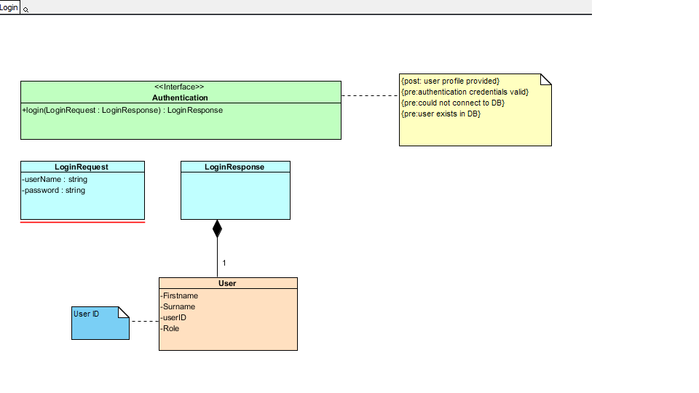

**Figure 10: Login Service Contract(copy the explanations from our previous doc)**

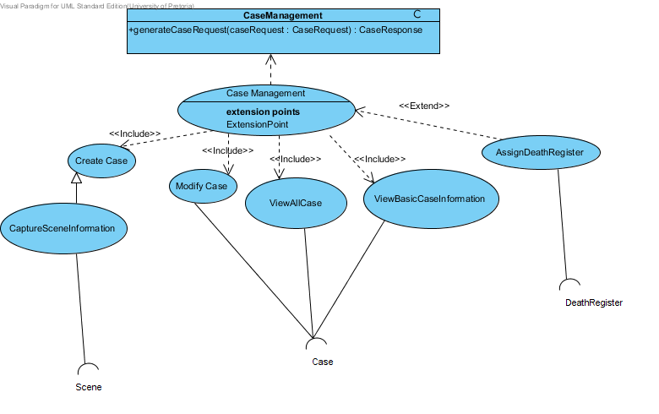

**Figure 11: Case management use case(copy the explanations from our previous doc)**

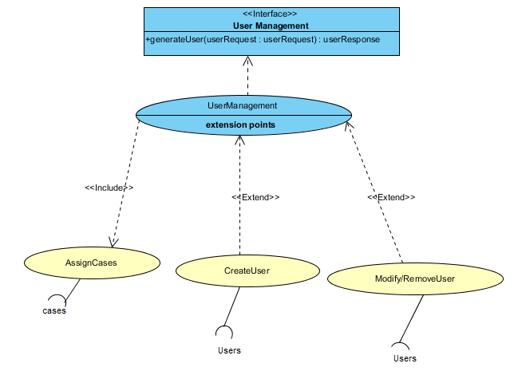

**Figure 12: Case management use case(copy the explanations from our previous doc)**

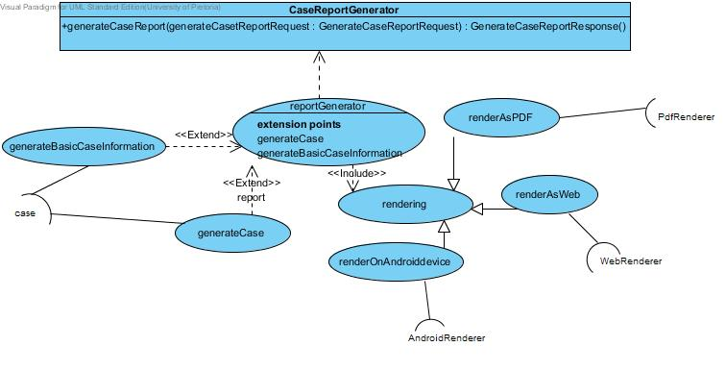

**Figure 13: Case management use case(copy the explanations from our previous doc)**

**6.5 process view of M-Forensics**

**Add Process View of Rhino here…. Chage it to suit our spec**

**Figure 12: process view use case**